Automation with Crontab Theory (1 hour): Scheduling tasks using crontab. Use cases for automation in Linux. Practical (1 hour): Automate backups of critical directories. Task: Submit a backup configuration and log output.

Tasks

1. List 3 real-life scenarios where automating tasks with crontab would be useful on a Linux server, and write one line explaining the benefit for each.

ANS:

- Database Backups — Schedule a daily mysqldump with crontab to automatically back up databases, reducing the risk of data loss.
- Log File Cleanup — Run a script weekly to delete or archive old log files, preventing logs from consuming excessive disk space.
- System Monitoring — Run a script every few minutes to check CPU, RAM, or disk usage and send an alert when usage exceeds a threshold.

2. Write a crontab entry that runs a script called update_playlist.sh every day at 2:00 AM to automatically update your music playlist backup, and explain what each part of the crontab line means.

ANS:

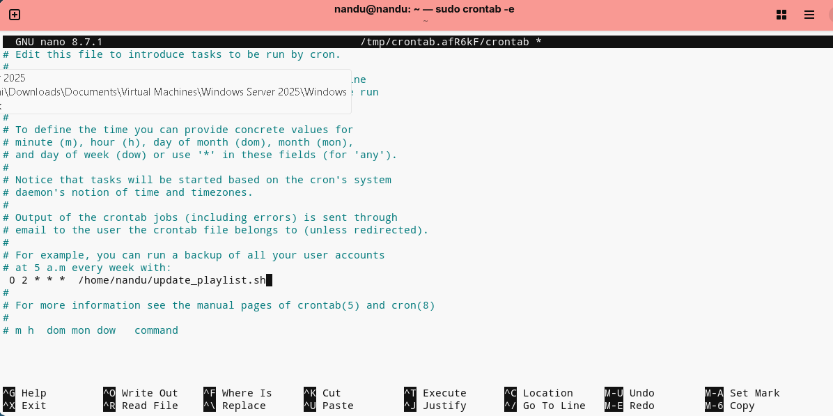

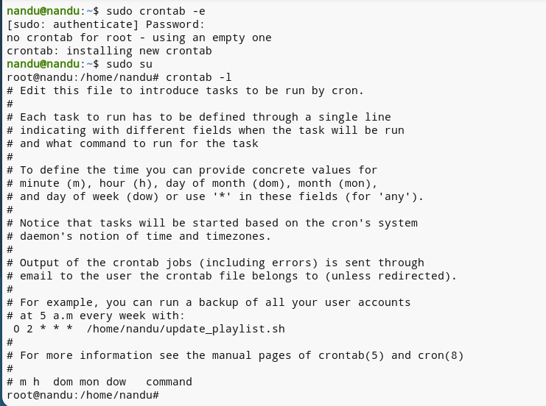

At 2:00 AM every day, Ubuntu will automatically run update_playlist.sh.

3. Create a shell script named backup_instagram_photos.sh that copies all files from /home/yourusername/InstagramPhotos to /home/yourusername/Backups/InstagramPhotos with today’s date in the backup folder name. Use the date command to generate a folder like InstagramPhotos_2024-06-10.

ANS:

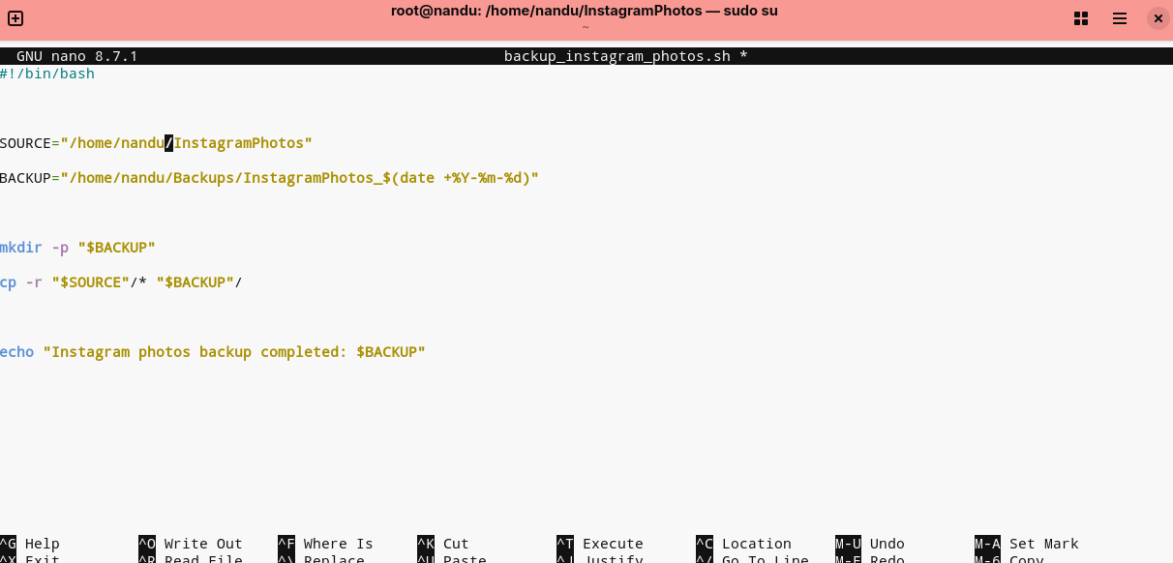

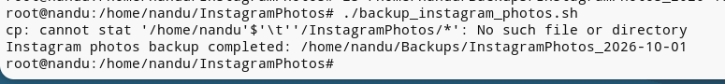

4. Schedule your backup_instagram_photos.sh script to run every Sunday at 11:30 PM using crontab, and redirect both standard output and errors to a log file named backup_log.txt in your home directory.

ANS:

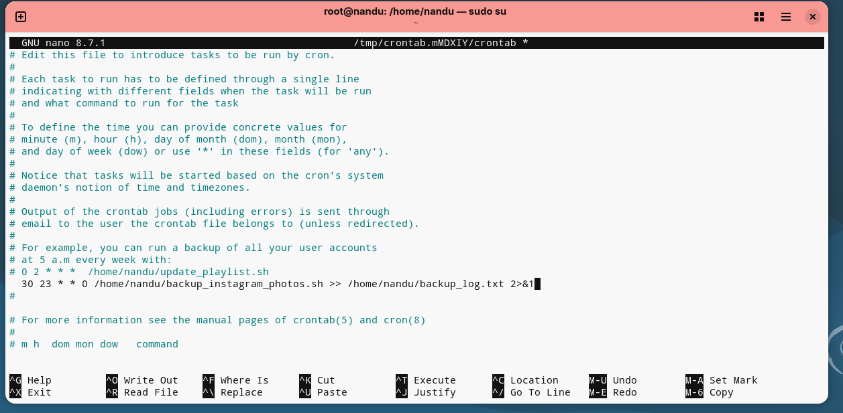

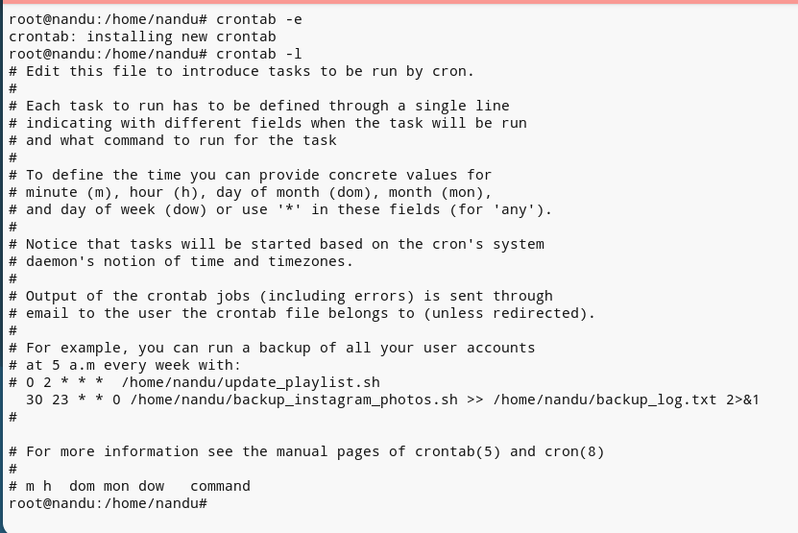

5. After your backup runs, open backup_log.txt and submit the last 5 lines as proof that your backup and logging worked. Use the tail command to view the last lines of your log.

ANS:

